Component 3 – TweetApp – Cloud Screenshots

**EKS POD Details**

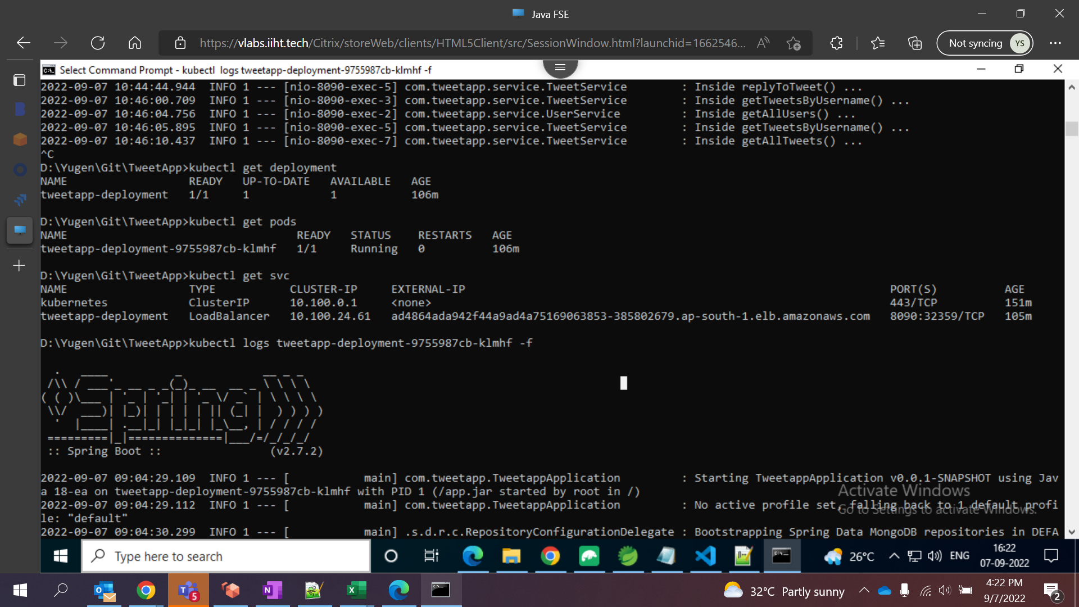

**EKS Cluster**

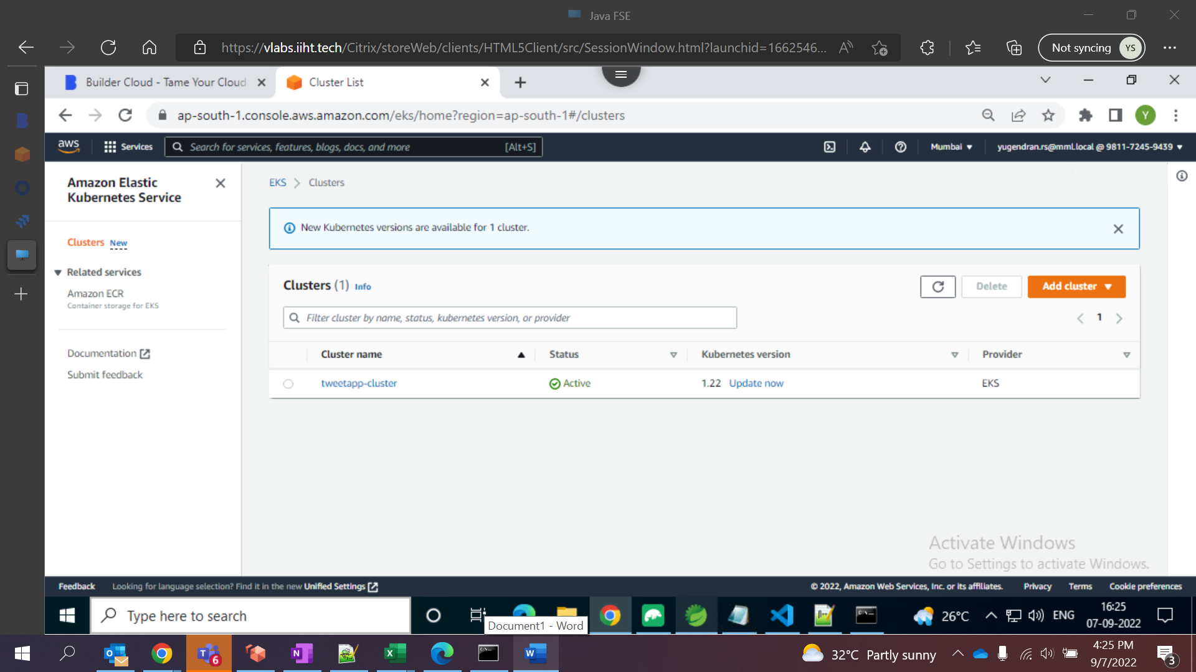

**Docker image on ECR Repo:**

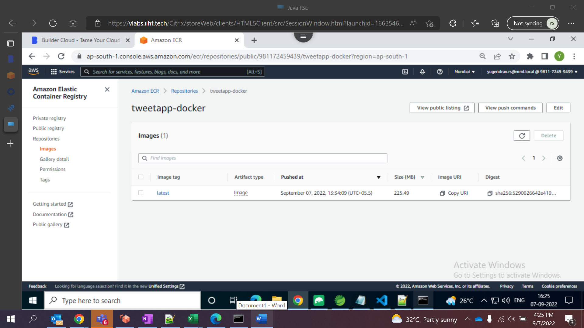

**Secret Manager to store MongoDB Connection String**

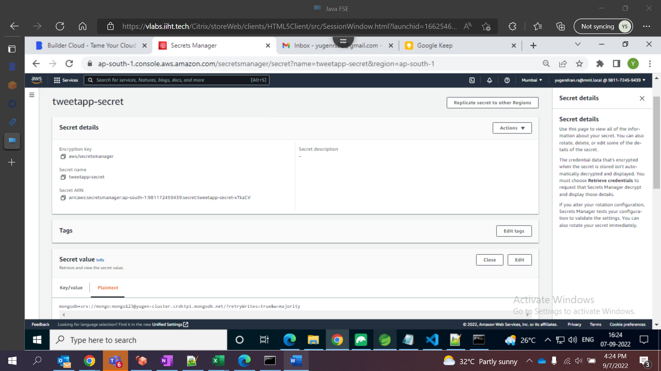

**S3 Bucket created to store React Code:**

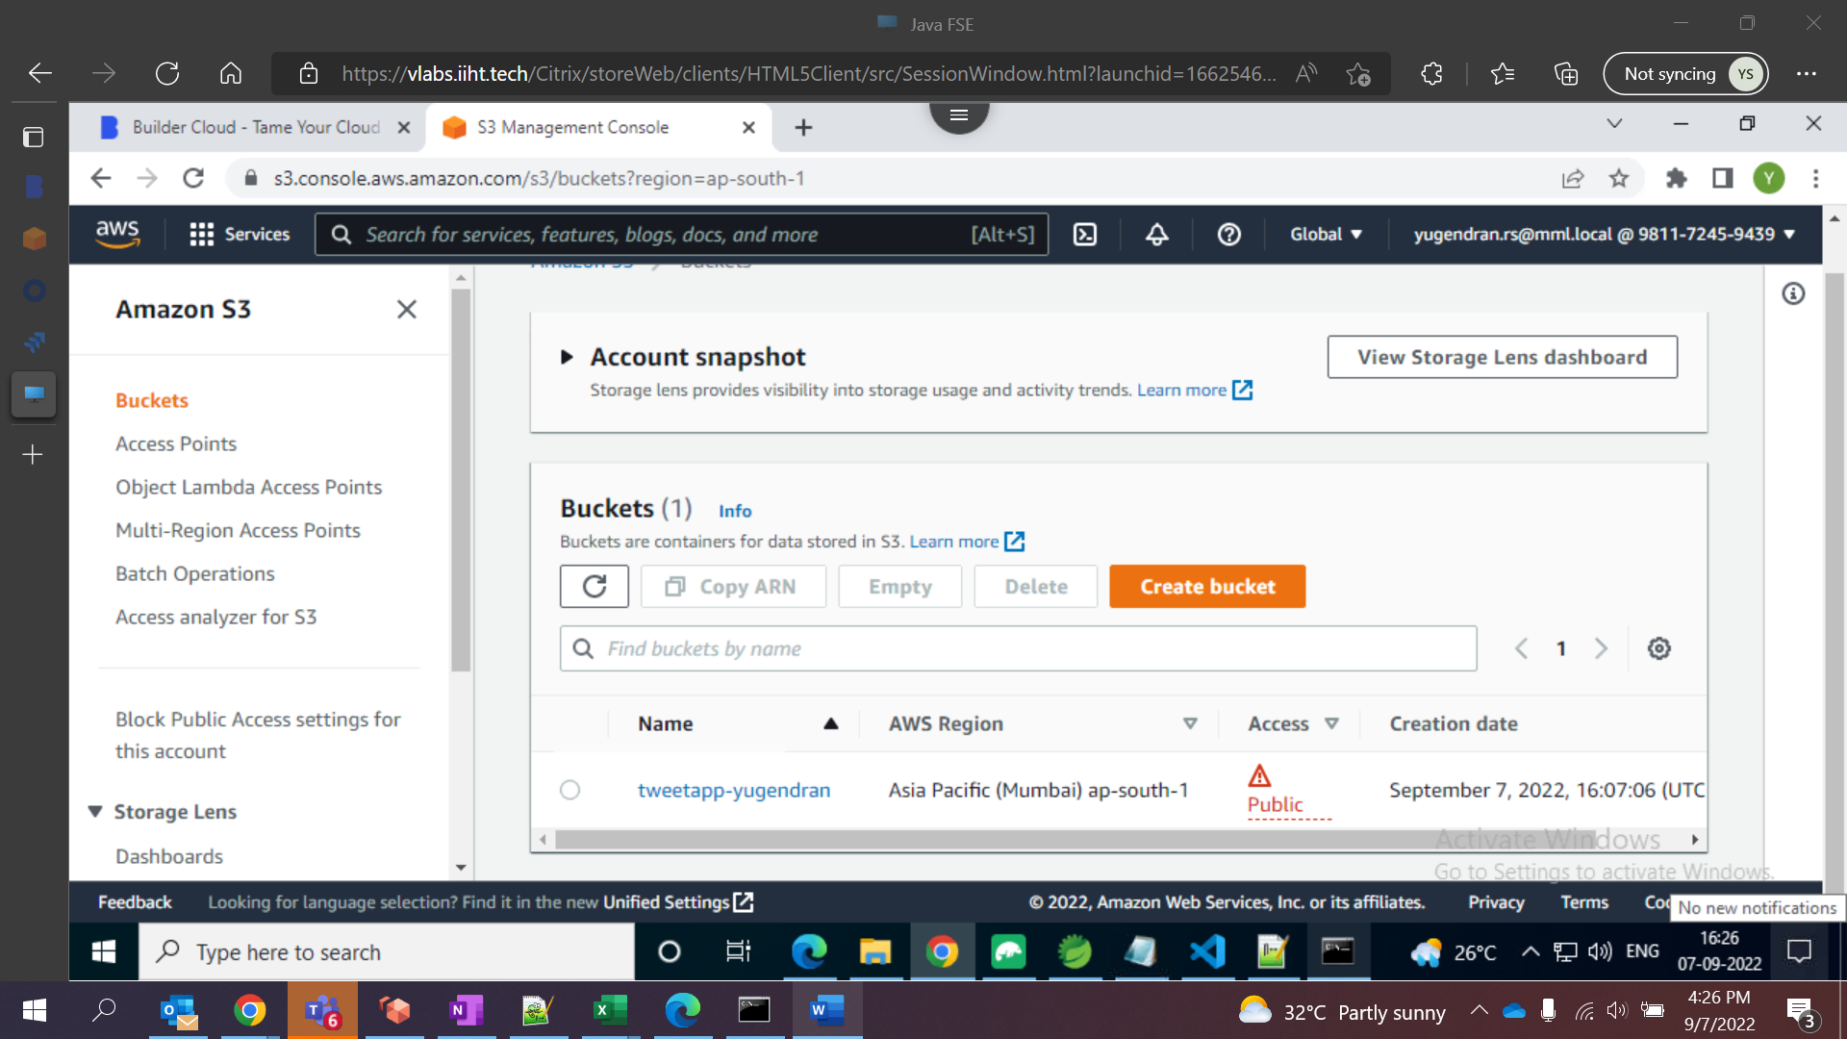

**Build Directory stored on S3 bucket**

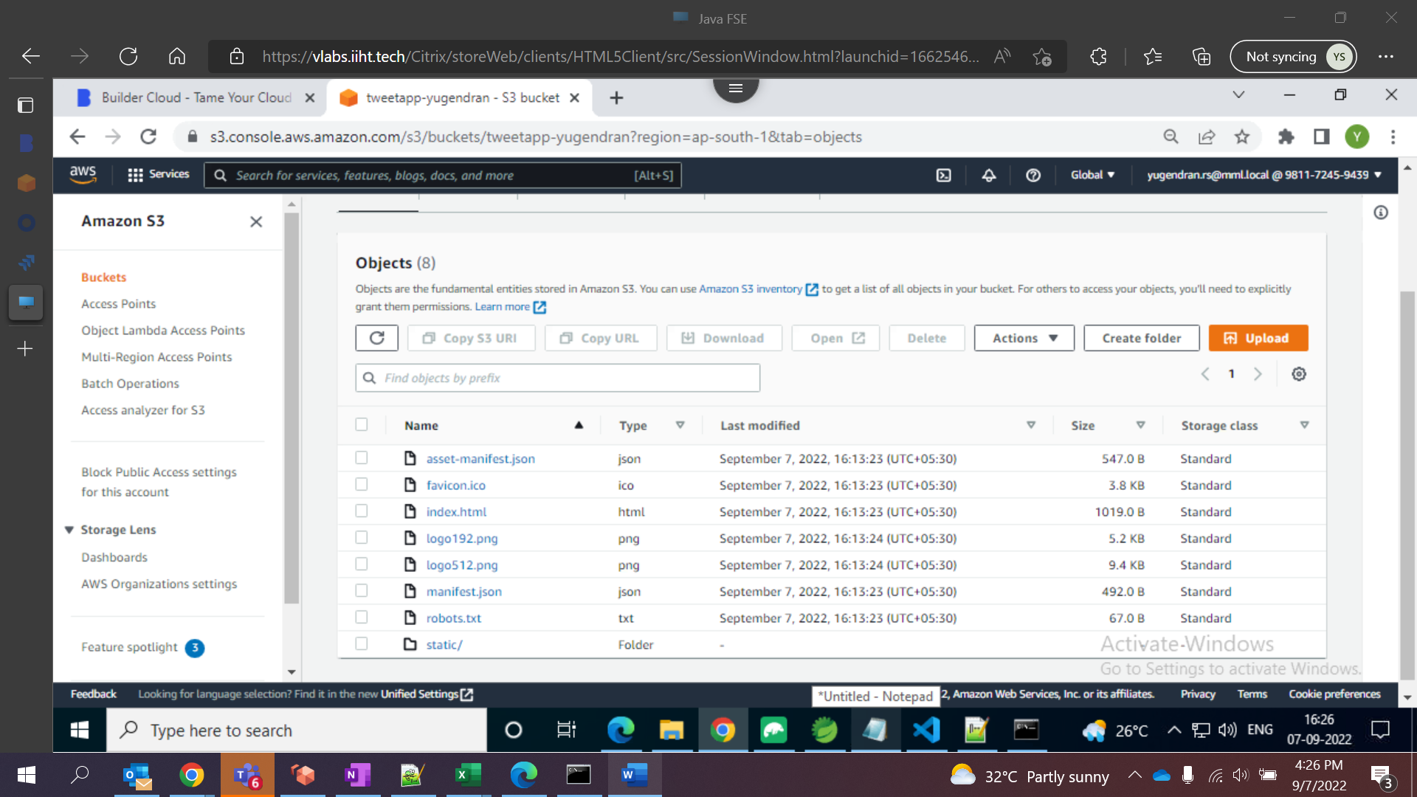

**Static Webhosting on S3**

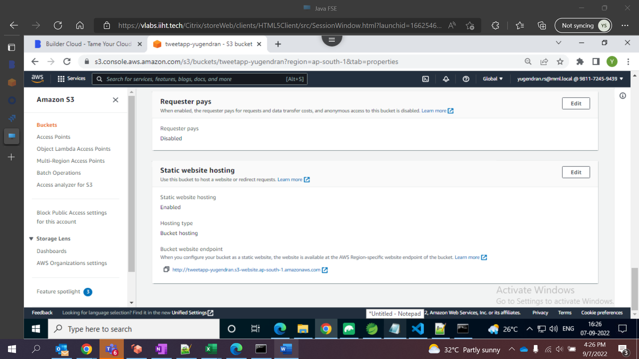

Application Live URL - [http://tweetapp-yugendran.s3-website.ap-south-1.amazonaws.com](http://tweetapp-yugendran.s3-website.ap-south-1.amazonaws.com/)

**Signin**

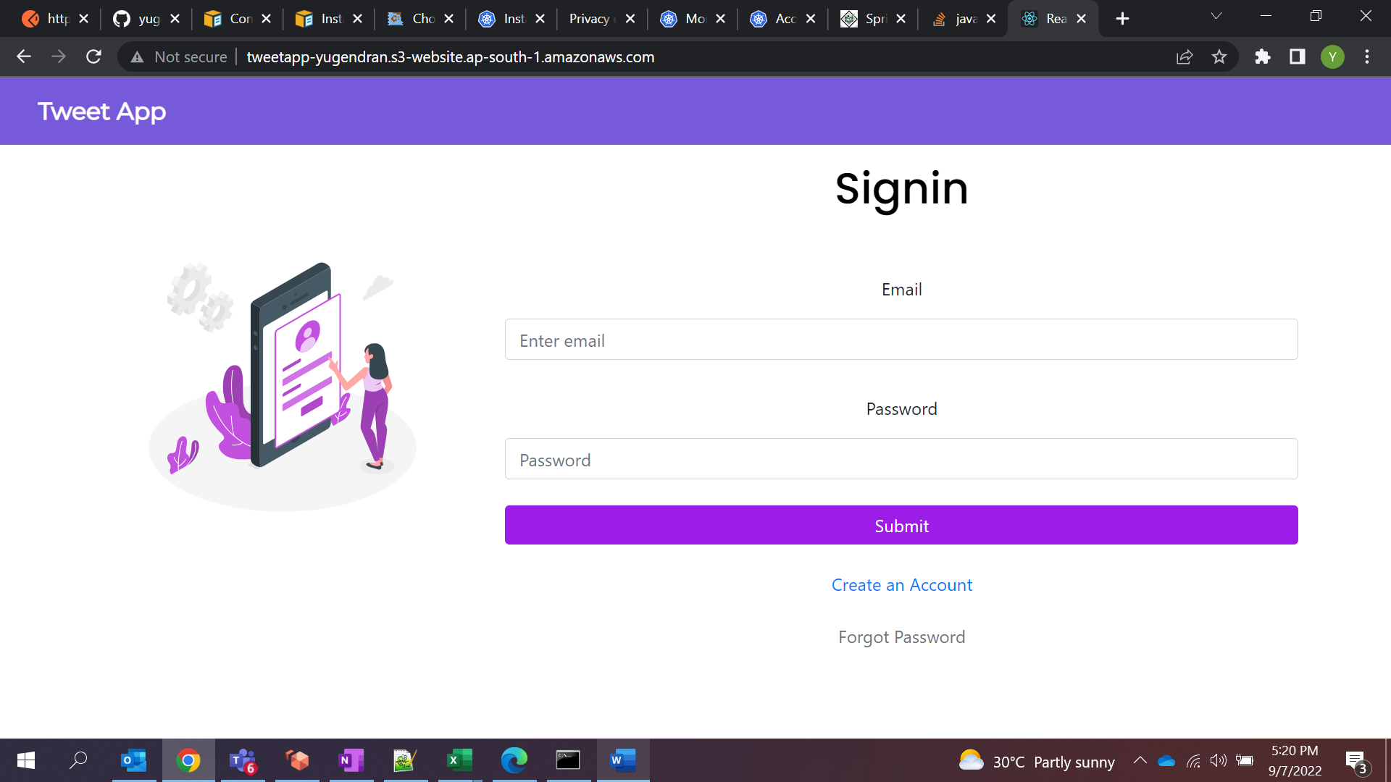

**All Tweets**

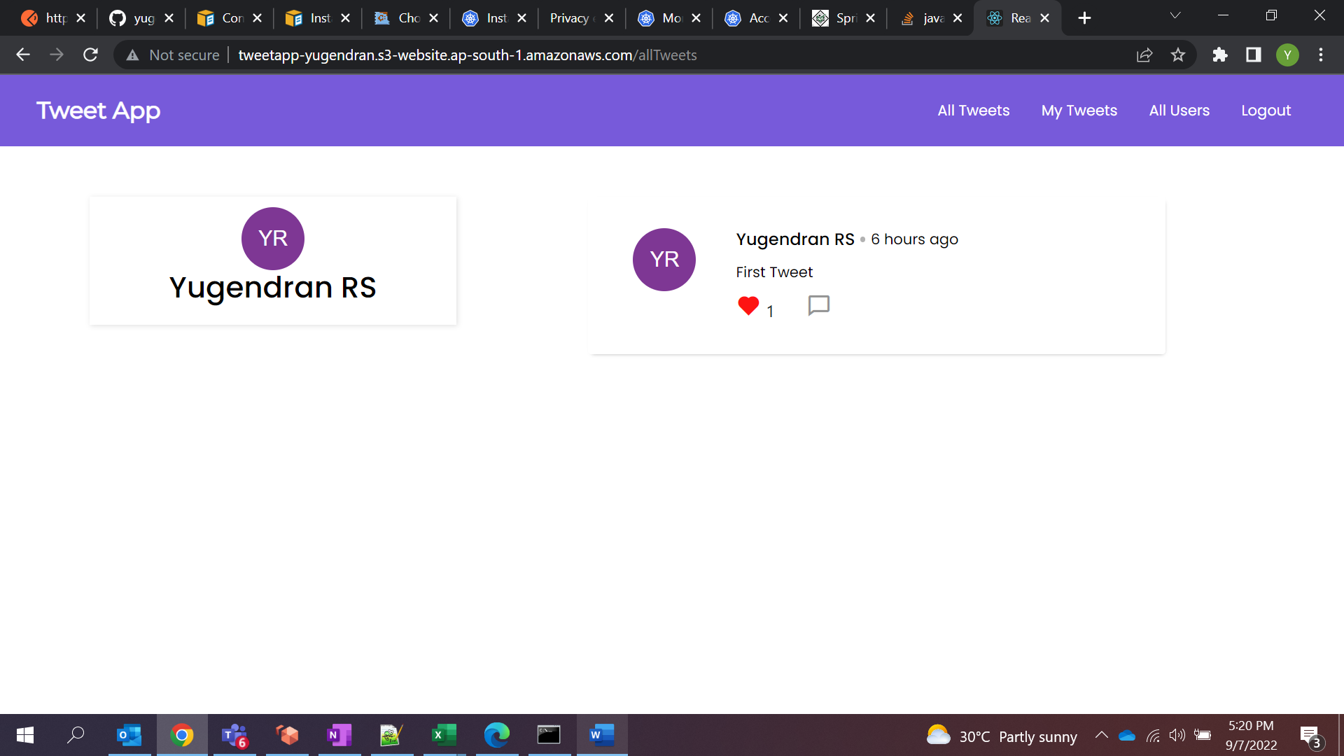

**My Tweets**

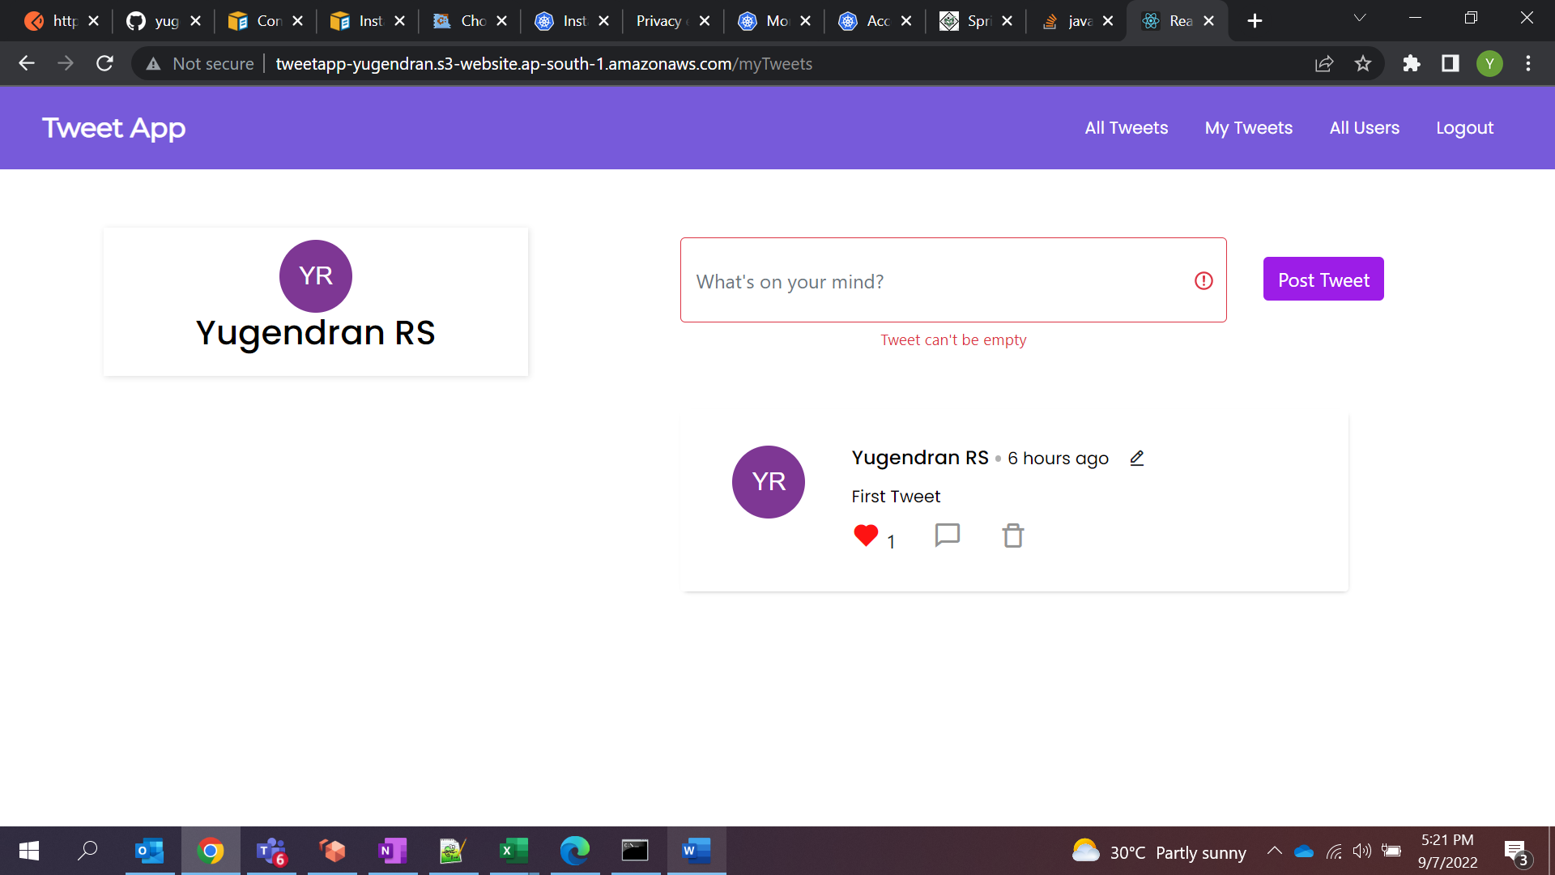

**Update Tweet**

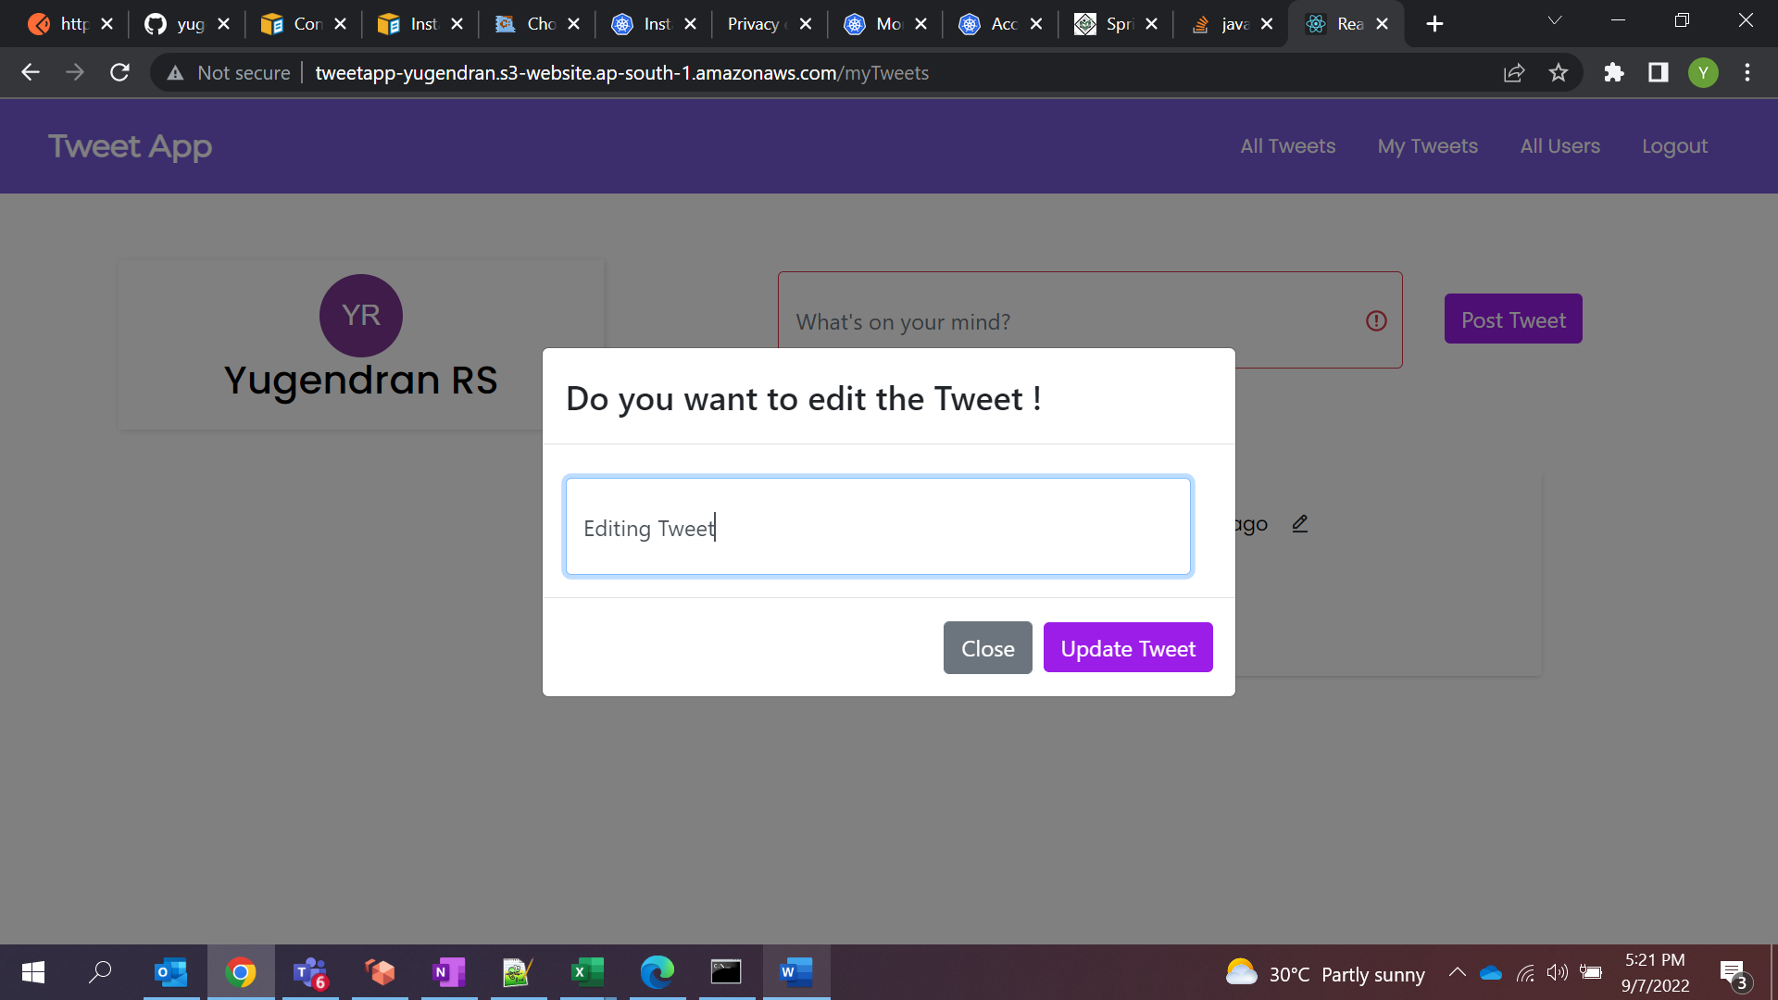

**All Users**

